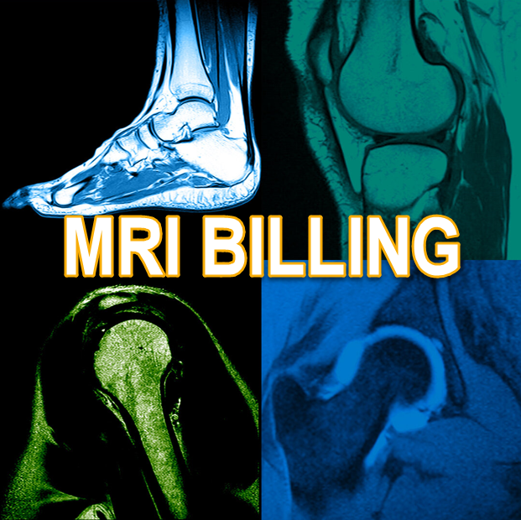

**Newport Orthopedic Institute** partners with **Newport Harbor Radiology Associates** to provide the best MRI result for you. We acquire the images in our office (this is called the ‘technical component’ of the MRI) and a ***Board-Certified Radiologist specializing in Orthopedics with Newport Harbor Radiology Associates*** interprets your images and provides the written report (this is called the ‘professional component’ of the MRI).

This means you will get 2 bills for your MRI, one from ***Newport Orthopedic Institute*** and one from ***Newport Harbor Radiology Associates.***

Just so you know, you are not paying more than you would if you used an office that billed a ‘Global’ charge that included both the ‘technical’ and ‘professional components’ in one bill. The same amounts are approved by your payer regardless of a ‘professional’, ‘technical’, or ‘global’ bill being submitted. That means your patient responsible amounts are also the same in any scenario.

***Newport Ortho billing phone: 949-722-5062***  ***Newport Harbor Radiology billing phone: 888-927-8020***

M: Revenue Cycle/Memos/02042025